**Dictionary Quiz Name:**

1. Consider the food dictionary of favorite foods and the students who have those favorite foods:

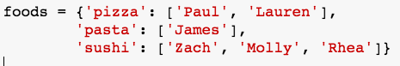

a. In one line, how would you update your dictionary to include that Jennifer likes burritos?

b. In one line, how would you update your dictionary to include that Megan likes pasta, too?

c. In one line, how would you remove Molly’s preference from the dictionary?

2. Consider the original dictionary. Write a program that prints the following output:

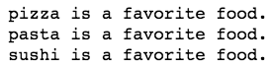

3. Consider the original dictionary. Write a program that prints the following output:

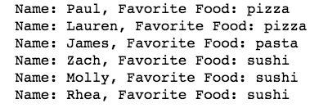

4. Consider the list of favorite foods:



From the fave_foods list, create a dictionary where the key is the food and the value is the frequency in which that food occurs. The output of your dictionary should be the following, in no particular order:



5. Consider the following recipe dictionary:



Write a code that prints out the following output:

